ICVFM-###

Full Paper Template for the 9th International Conference on

Vortex Flows Mechanics (ICVFM2021)

FirstName LastName^{1*}, FirstName LastName²

¹Institute, Address, City, Country
²Institute, Address, City, Country
* Corresponding Author: author@affiliation.com
ABSTRACT
This guide has been prepared for authors of full paper to be included in the Proceedings of the 9th International Conference on Vortex Flow Mechanics, ICVFM, to be held virtually on October 11-14, 2021. Authors are requested to follow these guidelines to achieve uniformity in the presentation of the proceedings. The abstract summarizes key findings in your study and should be a paragraph no more than 300 words. It should give an account of the most relevant contributions of the paper. It is also important to indicate briefly the goal, the methods, the results, and conclusions. No abbreviations, diagrams, and references should be included in the abstract. It must be complete and understandable without reference to the text.

KEYWORDS: Include three to six keywords, using Times New Roman, 11pt.
1. INTRODUCTION (Details for Submitting full paper)
The main format of the paper is as follows: Text: Times New Roman (or equivalent), 11 pt type size, left and right justified. Headings: Times New Roman, bold, all caps, 12 pt. type size, centered. Page size A4 (210 × 297 mm); 25.4 mm borders all round. Full Papers that do not follow the required format will be returned for corrections. If modifications to your paper are NOT required from the reviewers, it will be published as received.
2. FORMAT AND LAYOUT
The paper submitted using A4 size (210 by 297 mm) pages should be four pages at least. There is no upper limitation on the paper length. Pictures and tables should be included in the manuscript body. Section should be numbered, except for the Abstract, References and Acknowledgments.
2.1 Second-level headings
Second level headings should be in Times New Roman, all caps, bold, 12 pt., left aligned.

2.2.1 Third-level headings.
Third-level headings should be in Times New Roman, bold, italic, 12 pt., left aligned.

Equations should be typed in position with appropriate space above and below to distinguish them from the text. Use common fonts like Times New Roman in your math equations. Do not insert equations in a non-editable picture format. All equations should be centered, numbered as shown below. Equation numbers should be flush right with a line space above and below the equation.

(1)
(2)

Table captions should appear above the respective table. It should have a line space above the table and between the table and the start of the following text. Tables are in Times New Roman, 11 pt. size type, of 1 line heading, centered, if 2 line heading flush left. Type size of the body of the table depends on the size of the table, adjust type size accordingly.

Table 1 Table captions go above the table.
Template Style | Description
ICVFM title | BOLD, UPPER CASE, TIMES NEW ROMAN, 14 PT CENTERED
ICVFM authors | Bold, Times New Roman, 10 Pt, Centered
ICVFM affiliation | Italic, Times New Roman, 9 Pt, Centered
icvfm heading 1 | 2. Bold, Times New Roman, 12 Pt Centered, all caps
iCVFM heading 2 | 2.1 Bold, times new roman, 12 pt, left, all caps
ICVFM heading 3 | 2.1.1 Third-level headings
ICVFM body text | Times New Roman, 11 Pt, Justified
ICVFM table fig caption | Table, Figure title captions, Times New Roman, 11 Pt, Left
ICVFM equation | Tab 7.5 cm center, 15.75 cm Right
ICVFM reference | 11 Pt, Hanging 0.63 cm

Color and black/white photographs are allowed in digital format with sufficient resolution to permit high-quality reproduction and imported into the manuscript. Figures are centered with a line space above and below the figure. Use or insert .jpg, .tiff, .gif, or similar program files for illustrations.

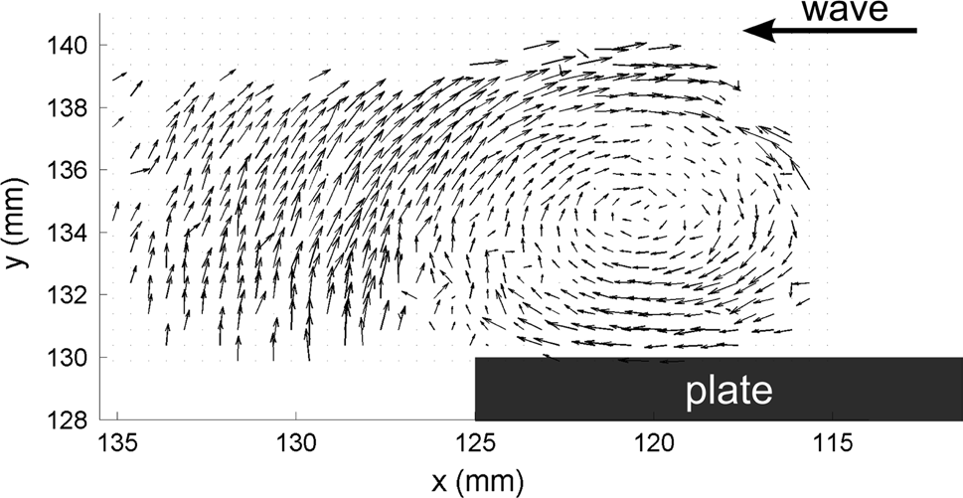
Fig. 1 Figure captions are center under the figure [1]

Figures should be numbered consecutively, e.g., Fig. 1 with a single space between the word “Fig.” and the Arabic numeral. Place figures centered on the width of the text page and either at the top or bottom of the page as close as possible to their first mentioned in the text.
3. SUBMISSION
Please submit your full paper before September 15, 2021, as follows: a PDF file should be uploaded at https://easychair.org/conferences/?conf=icvfm2021, replacing the previously submitted abstract and a Word file should be sent via e-mail to <icvfm@upatras.gr>.
4. CONCLUSIONS
Paper Size and Length: A4 (210 × 297 mm) and 4 pages at least.
Margins: 25.4 mm (1 inch) margins all round.
Line Spacing: Single-spaced with one blank line between paragraphs. No paragraph indentation.
Justification: Full justification.
Submission: Full papers should be submitted for review, before September 15, 2021, as follows: a PDF file should be uploaded at https://easychair.org/conferences/?conf=icvfm2021 replacing the previously submitted abstract and a Word file should be sent via e-mail to <icvfm@upatras.gr>.
ACKNOWLEDGMENT
Acknowledgement should be placed immediately following CONCLUSIONS, if necessary.
Reference
[1] Lebon B, Perret G, Coëtmellec S, et al. A digital holography set-up for 3D vortex flow dynamics[J]. Experiments in Fluids, 2016, 57(6):1-11

